NAME :p.kalyan

REG NO :192110675

COURSE :software engineering

CODE :CSA1001

FACULTY :Mary valantina

DATE :28/9/22

**LAB MANUAL 11 TO 17**

**EXPERIMENT:11**

11.Draw a Class diagram for Library Management System using CASE tools.

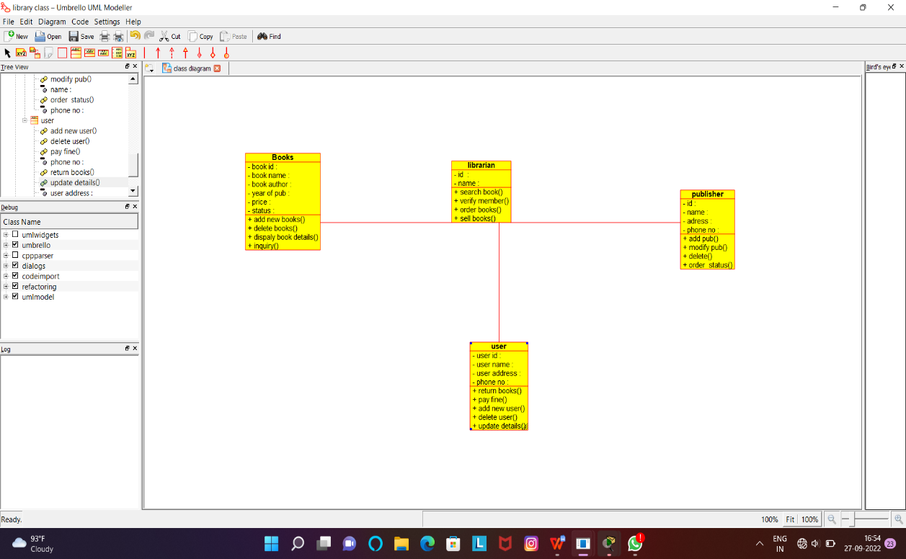

RESULT:Successfully designed this experiment using umbrello tool

**EXPERIMENT:12**

12.Draw a Class diagram for Online Shopping system using CASE tools.

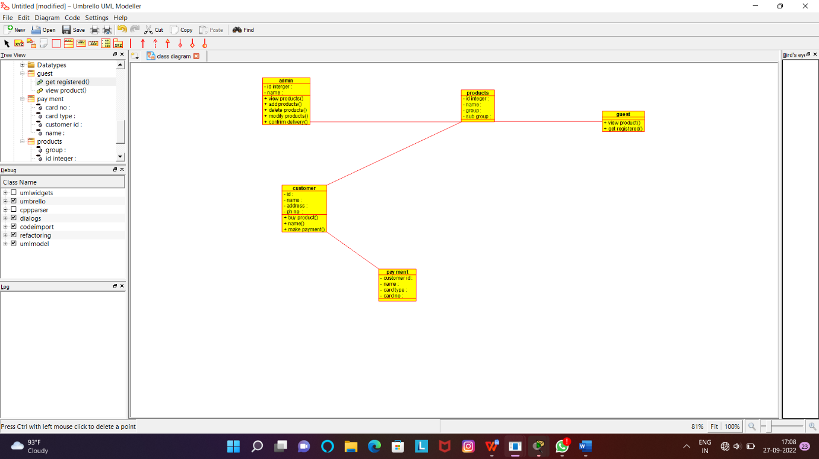

RESULT:Successfully designed this experiment using umbrello tool

**EXPERIMENT:13**

13.Draw a Class diagram for Online Railway Reservation System using CASE tools.

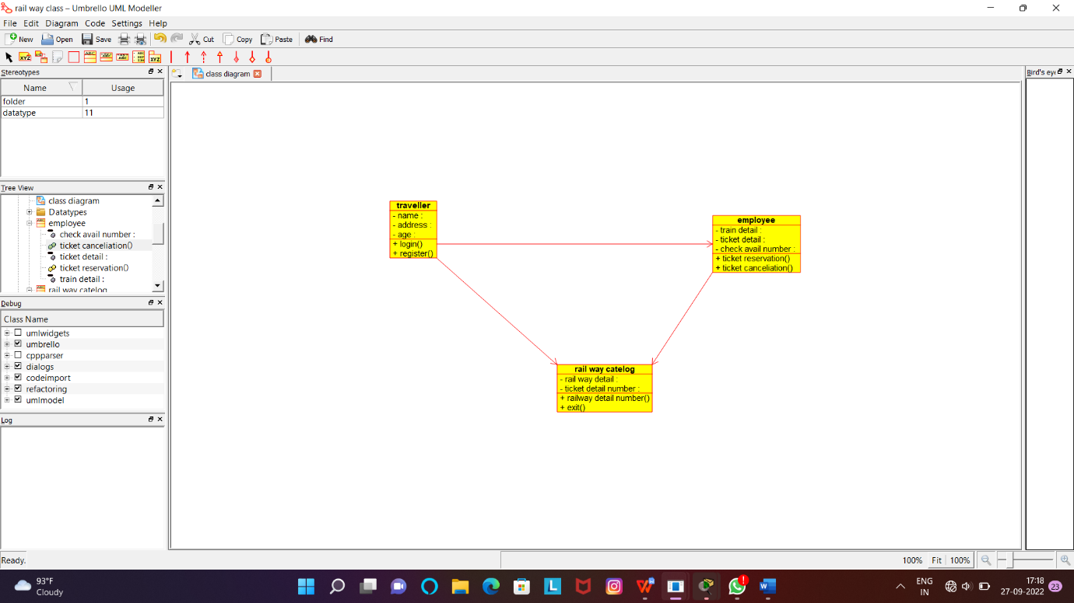

RESULT:Successfully designed this experiment using umbrello tool

**EXPERIMENT:14**

14.Draw a Activity diagram for Online Voting System using CASE tools

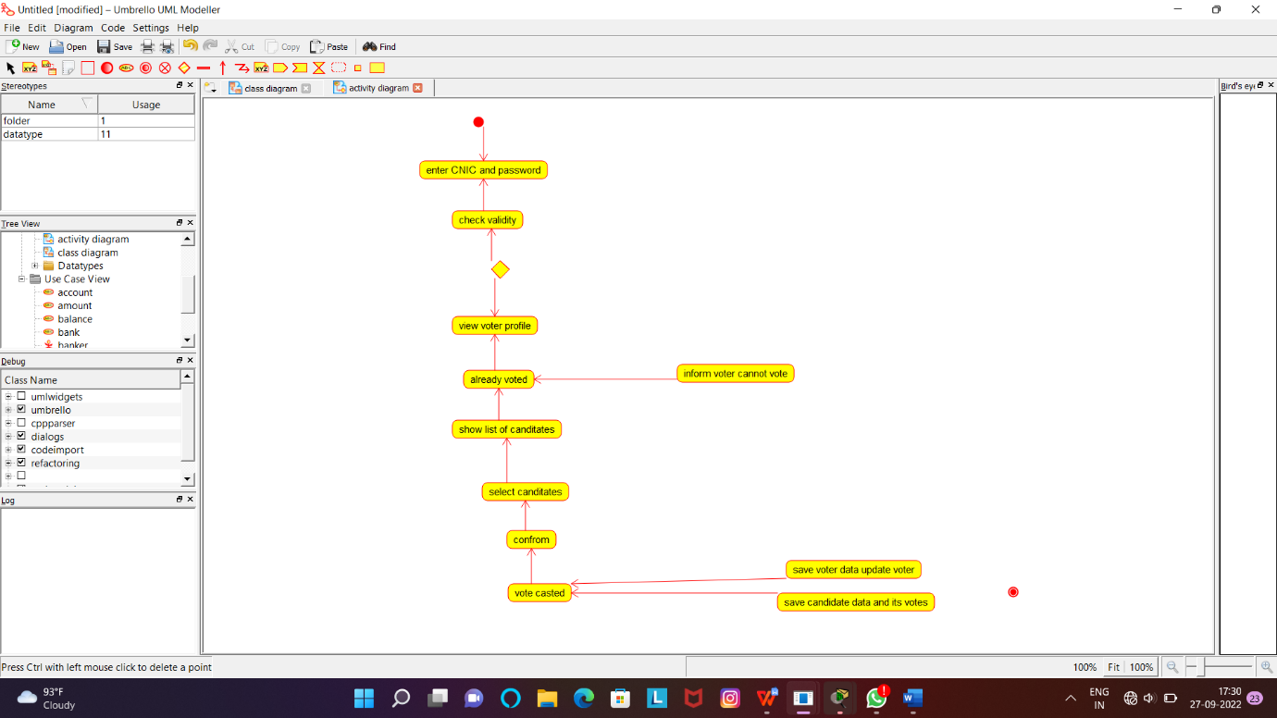

RESULT:Successfully designed this experiment using umbrello tool

**EXPERIMENT:15**

15.Draw a Activity diagram for Library Management System using CASE tools.

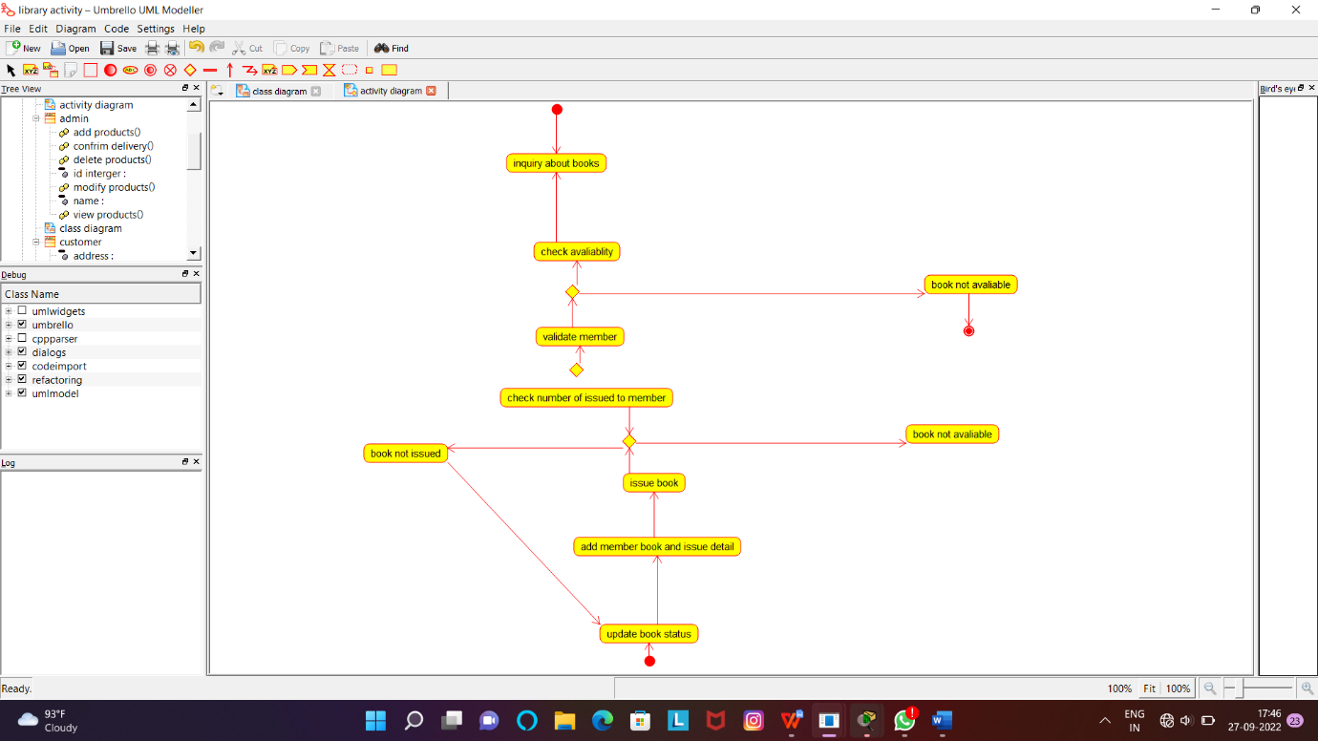

RESULT:Successfully designed this experiment using umbrello tool

**EXPERIMENT:16**

16.Draw a Activity diagram for Online Shopping system using CASE tools.

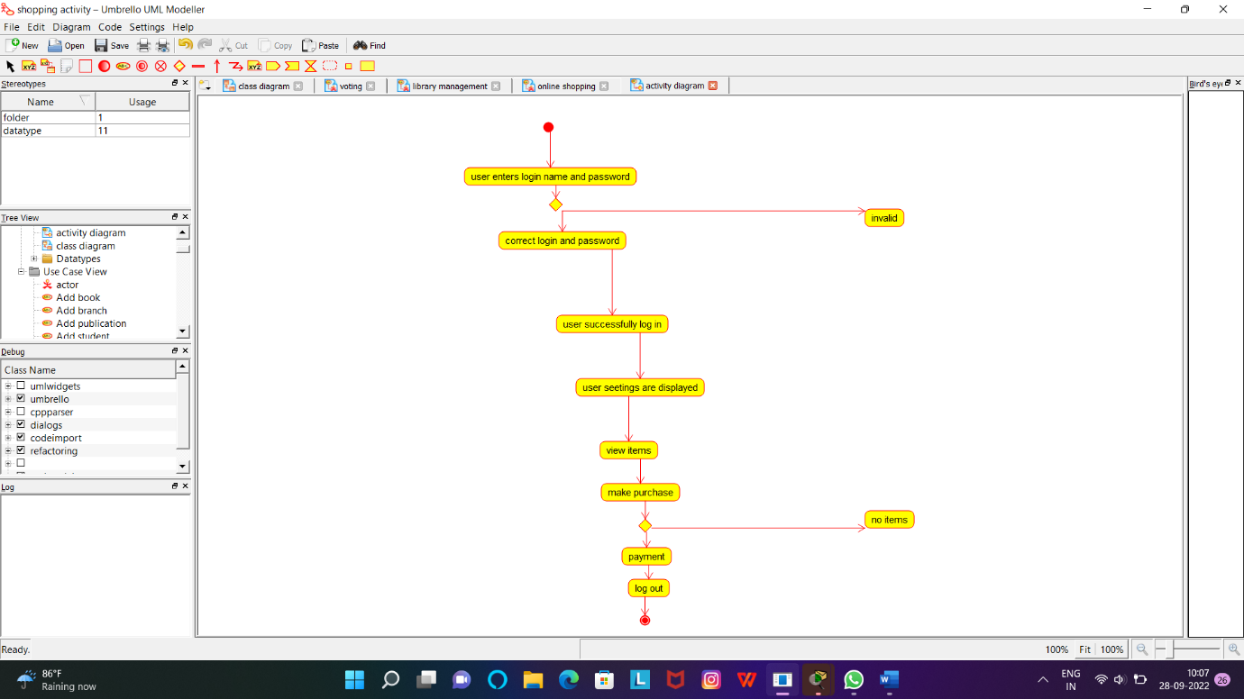

RESULT:Successfully designed this experiment using umbrello tool

**EXPERIMENT:17**

17.Draw a Activity diagram for Online Railway Reservation System using CASE tools.

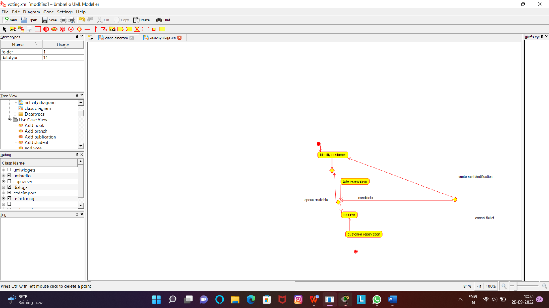

RESULT:Successfully designed this experiment using umbrello tool